**Date: Sunday, September 15, 2024**

**Gettysburg Area Recreation Park**

**Time: 12 noon until 4 pm**

**Thirty-Third Annual**

**Adams County**

**Heritage Festival**

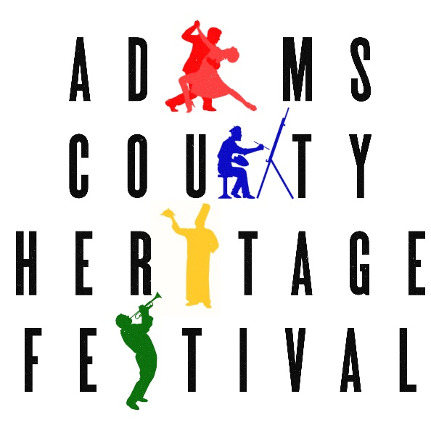

**Application form for Crafts & Other Vendors**

Your name

Your organization’s name (if applicable)

Mailing address

Phone (day) (evening)

Email

* Yes, I/we want to participate in the Thirty-Third Annual Heritage Festival. Please sign me/us up for the booth ($25 fee) listed below.

Crafts or Artwork to sell (please describe):

Other (please describe):

DO YOU NEED ELECTRICITY? ❑ Yes ❑ No

Please bring your own heavy-duty outdoor extension cord. Since there are a limited number of electrical outlets, access to electricity will be on a first-come, first-served basis.

Employee Tax-ID Number (EIN) or Social Security Number

Pennsylvania Sales Tax License Number

For more information, email [achf@icpj-gettysburg.org](mailto:achf@icpj-gettysburg.org) or visit [icpj-gettysburg.org/festival/](icpj-gettysburg.org/festival-2/).

*Please read the regulations and sign the release on the other side.*

**Regulations**:

**General**

1. Booths are 10’ x 10’. Please center your exhibit within the marked booth lines.
2. All set-ups must be completed NO LATER THAN 11:30 AM.
3. All participants should unload and then park their vehicles. No vehicles will be allowed in the Festival area between 11:30 am and 4:00 pm. **It is especially important that no vehicles cross the path of the Bicycle Parade, between 1 and 2 p.m.**
4. All participants should be prepared to stay until 4:00 pm. Please do not begin taking down your booths and set-ups until 4:00 pm.
5. All participants will receive a map of the layout of booths, set-ups, and parking areas.
6. All entertainment, exhibits, and merchandise must be consistent with the purpose of the Heritage Festival and the missions of the Interfaith Center for Peace and Justice and the YWCA Gettysburg and Adams County.

**Crafts & Other Vendors**

1. Cost of booth (10’ x 10’) for crafters and other vendors is $25.
2. If you need a canopy, please bring your own.
3. Please bring a sign for your booth and the means for attaching it.

**Fees:**

Booth ($25)

**TOTAL enclosed**

**Release**

I/we the applicant(s) do expressly release the organizers of the Adams County Heritage Festival, the Gettysburg Area Recreation Authority, the YWCA Gettysburg & Adams County, and the Interfaith Center for Peace and Justice and any individuals associated with these civic, governmental, and non-profit organizations from any and all liability for any damage, injury, or loss to any person or goods that may arise from the rental and occupation of exhibit space by the applicant(s) and agree to hold and save the Adams County Heritage Festival, the Gettysburg Area Recreation Authority, the YWCA Gettysburg & Adams County, and the Interfaith Center for Peace and Justice harmless of any loss or damage by reason thereof.

I/we understand that my/our fee shall not be refunded in the event that I/we do not attend, unless I/we have notified the Adams County Heritage Festival prior to August 15, 2024.

I/we assume complete responsibility for collection and payment of Pennsylvania state sales taxes.

Signature(s) Date

Please mail this form with your fee to:

**Adams County Heritage Festival**

P.O. Box 3134

Gettysburg, PA 17325

**Deadline:** August 15, 2024 (No refund after August 15, 2024)

**Questions?** Call (717)334-0752, email [achf@icpj-gettysburg.org](mailto:achf@icpj-gettysburg.org), or visit [icpj-gettysburg.org/festival](http://www.icpj-gettysburg.org/festival-2)/.